Automated Retinal Disease Classification from OCT Images Using a Lightweight CNN–SE Architecture

Parth R. Dave¹., Nikunj H. Domadiya²

¹ Research Scholar, Gujarat Technological University, Ahmedabad, Gujarat, India
^{1,2} Assistant Professor, Computer Engineering Department, L. D. College of Engineering, Ahmedabad, Gujarat, India
Corresponding author: Nikunj H. Domadiya (e-mail: domadiyanikunj002@gmail.com), Author(s) Email: Parth R. Dave (e-mail: prd7889@gmail.com)
Abstract In recent times Artificial Intelligence is playing the important role in many fields of medical science. Ophthalmology is a field of medical science in which the disease related to front and back end of the eye is measured and according to that the treatment is provided. The backend of the eye is called retina which is responsible to send the electromagnetic signals to the brain through optic nerve system. Optical Coherence Tomography (OCT) is an imaging method that allows retina specialists to examine the internal structure of the eye in detail. This method contributes to the accurate identification of different retinal disorders: Age-Related Macular Degeneration (AMD), Central Serous Retinopathy (CSR), Macular Hole (MH), Diabetic Retinopathy (DR), Drusen, Diabetic Macular Edema (DME) and Choroidal Neovascularization (CNV). However, manual analysis of OCT images is really time-consuming and subjective according to the domain knowledge of the specialist. Applying deep learning for the automatic classification of retinal diseases from OCT images is valuable for achieving timely, reliable, and early-stage detection of the anomalies. On the top of it many anomalies are having feature overlapping conditions which have to be addressed in detail. To improve the current diagnostic process, this study presents a lightweight CNN-based model for the automated classification of retinal OCT images. The present study develops a computationally efficient model that provides high diagnostic accuracy without the use of complex architectures or transfer learning techniques. In this study, we propose an effective thirteen-layer Convolutional Neural Network (CNN) incorporating Squeeze-and-Excitation (SE) blocks, along with data augmentation and the Adam optimizer. The proposed framework was trained and assessed on OCT-C8 and OCT2017 dataset, which comprises the seven and three classes of abnormalities consecutively and one class as a normal retinal structure in both the datasets. Our proposed approach achieved 97.00% and 99.00% of accuracy while testing on the OCT-C8 and OCT2017 datasets consecutively. The proposed CNN-SE model is a generalized model which achieves faster and accurate inference through a lightweight design.
Keywords Convolutional Neural Network; Artificial Intelligence; Machine Learning; Deep Learning; Optical Coherence Tomography
- Introduction
Optical Coherence Tomography (OCT) is a valuable imaging technique used for the early detection of retinal diseases. It generates high-resolution tomographic images of retinal tissue that enables accurate detection of structural abnormalities within the retina part and macula part. Retinal diseases sometimes may result into irreversible vision loss and therefor the early detection of the abnormalities is essential. Retinal OCT imaging is widely used in ophthalmology to assist in treatment planning and to monitor the success of treatments such as laser therapy, eye injections, and surgical interventions. There are several factors that can lead to retinal disorders, such as genetic defects, stress, aging, lack of physical activity, excessive screen exposure, and unhealthy eating habits. As a result, retinal diseases are becoming more common, making it essential to carry out fast, precise, and consistent evaluations. Automated retinal OCT image classification techniques can be helpful as a suggestive system to the doctors which provide impartial, reliable and diagnostic consistencies for pointing out the abnormalities.
Conventional machine learning algorithms use texture-based detailing retrieved from images to represent local or global information. Various feature extraction techniques such as Local Binary Pattern (LBP) [1], Histogram of Oriented Gradients (HOG) [2], Gray-Level Co-Occurrence Matrix (GLCM) [3], edge detection, and shape detection are applied to obtain a discriminative feature vector. The extracted feature representation is then fed into supervised learning classifiers, including Artificial Neural Networks (ANN) and Support Vector Machines (SVM) [4], or other classifiers to perform the final image classification. However, one major limitation of classical machine learning approaches is that they depend on manually extracted features instead of learning the features directly from the data. Since the image representation relies only on predefined feature descriptors, some important information from the original image may be lost during the feature extraction process. This loss of information can affect how well the model understands the data and may lead to lower accuracy and reduced overall performance of the classification system.
In recent years, advanced computational techniques have gained significant attention in the field of computer vision, as it can automatically extract complex patterns and important features from input images without requiring manual feature engineering. Convolutional Neural Networks (CNNs), in particular, have significantly changed the way image-related tasks are approached which is actually outperforming various traditional and shallow learning methods in several aspects.
In past few years, computer vision has witnessed remarkable growth, supported by the emergence of several pre-trained models capable of extracting meaningful information from complex visual data, including NASNetMobile [5], AlexNet [6], VGG16 [7], VGG19[7], ResNet50[8], and GoogLeNet [9], transformer models and lightweight models. These architectures are trained on large and diverse image databases, which helps them learn diverse visual features and patterns. Owing to the rich feature representations acquired during training, these models can be effectively applied to extract features from new image datasets.
Automated OCT image analysis plays a crucial role as a suggestive system between patient and a doctor to identify the anomalies in a grater detailed manner. Many efforts have been carried out over the years to achieve this by applying conventional and contemporary machine learning algorithms with various techniques.
P. P. Srinivasan et al. [10] performed image reshaping, noise reduction and cropping the retinal images to extract Histogram of Oriented Gradients (HOG) descriptors [2]. For multi-class classification, a Support Vector Machine (SVM) classifier [4] was used with a one-versus-one strategy, resulting in three linear SVM classifiers corresponding to the three dataset classes: AMD, DME and Normal. The retinal image dataset used in the study was locally developed using OCT images collected from patients with different retinal disorders. Y.-Y. Liu et al. [11] presented proposed a traditional OCT image classification method using multi-resolution and PCA-based LBP features. An SVM classifier was employed to classify MH, ME, and AMD from a locally collected dataset. Alsaih K et al. [13] proposed a conventional OCT classification approach using Histogram of Oriented Gradients (HOG) [2] and Local Binary Patterns (LBP) [1] features with PCA for feature reduction. The optimized features were classified using an Support Vector Machine (SVM) [4] on a locally collected dataset.
On the other hand, several advanced techniques have been proposed for the classification of retinal OCT images. L. Huang et al[14] developed a layer-based CNN that learned features from individual retinal layers for OCT image classification. The extracted features were combined using transfer learning, achieving improved performance on the OCT2017 [15] and HUCM [14] OCT image datasets. J. Kim and L. Tran [16] proposed a two-stage deep learning model for OCT image classification. U-Net-based ROI extraction and image alignment enhanced feature learning, leading to better accuracy than L. Huang et al. [14] on OCT2017 [15] dataset. Shengyong Diao et al. [17] proposed CM-CNN and CAM-UNet for AMD classification from OCT images. Their approach improved region localization and achieved promising performance. Hassan E. et al. [18] proposed the EOCT framework, combining ResNet-50 [8] feature extraction with a Random Forest classifier for OCT image classification. The model, trained using SGD and Adam, achieved state-of-the-art performance. On OCT2017 dataset [15].
In [19], authors proposed OCTx, an ensemble deep learning model for four-class OCT image classification. It achieved strong performance but was evaluated on a limited dataset. In [20], the authors presented a CNN model using ImageNet pre-trained weights for three-class retinal OCT image classification. Fine-tuning and ensemble learning increased the classification accuracy from 68.17% to 92.89%.
In [21], the authors evaluated AlexNet, VGG, Inception, and ResNet for retinal OCT image classification. The Inception model with RMSprop achieved the best results, reaching 95.53% accuracy and an F1-score of 0.93687. In [22], the authors applied NasNetMobile [5] to classify eight retinal diseases using the OCT-C8[23] dataset. Among the tested optimizers, SGD delivered the best results with 97% accuracy and stable convergence within 22 epochs. Dave and Domadiya et al. [24] formulated a CNN-based model for retinal OCT image classification. Using hybrid pooling, data augmentation, and learning rate decay, the model achieved 98.75% accuracy on the OCT2017 [15] dataset. A thorough analysis of earlier machine learning and deep learning approaches used for OCT image classification is summarized in Table 1.

Table 1:Overview of Existing Approaches for Retinal OCT Image Classification
Reference | Category | Dataset Used | Key Methodology | Limitation
Y.-Y. Liu et al. [11] | Machine Learning | Local dataset | SVM classifier using both global and local image features | Classification performance is highly dependent on accurate feature extraction and image alignment.
Alsaih K et al. [13] | Machine Learning | Local dataset | HOG, LBP, and PCA features combined with an SVM classifier | Relies on handcrafted feature engineering, which may reduce adaptability to diverse datasets.
L. Huang et al. [14] | Deep Learning | OCT2017, HUCM | Layer-guided CNN developed using transfer learning | Requires retinal layer segmentation before classification, increasing preprocessing complexity.
J. Kim and L. Tran [16] | Deep Learning | OCT2017 | U-Net-based preprocessing with image rotation followed by binary CNN classifiers | Multiple preprocessing stages increase computational complexity and execution time.
S. Diao et al. [17] | Deep Learning | Not specified | CM-CNN integrated with CAM-Unet for retinal image analysis | Separate segmentation and classification networks make the framework more complex.
Hassan E et al. [18] | Hybrid Learning | OCT2017 | ResNet-50 used for feature extraction followed by a Random Forest classifier (EOCT) | Hybrid architecture requires additional training effort and higher implementation complexity.
D. Paul et al. [19] | Ensemble Deep Learning | OCTx, OCT2017 | Ensemble of multiple deep learning models for retinal OCT classification | Limited training data may restrict the model's ability to generalize to unseen clinical images.
Yang J et al. [20] | CNN Ensemble | OCT2017 | Ensemble learning strategy combining multiple CNN models | Increased memory usage and computational requirements during training and inference.
Stanojević et al. [21] | Deep Learning | OCT2017 | Comparative evaluation of CNN models with InceptionV1 showing the best performance | High computational demand limits its suitability for real-time applications.
Madhumithaa S et al. [22] | Deep Learning | OCT-C8 | NasNetMobile architecture optimized using the SGD optimizer | Computationally demanding, making deployment on resource-limited systems challenging.
Dave and Domadiya et al. [24] | Deep Learning | OCT2017 | CNN architecture incorporating hybrid pooling with an optimized training strategy | Validation was limited to four retinal disease categories, reducing its broader applicability.

Even while current approaches have demonstrated promising outcomes, many still rely on computationally costly deep learning models or intricate preprocessing. Several methods are challenging to apply effectively because they call for distinct stages for feature extraction or segmentation. Furthermore, their robustness and generalizability in practical clinical applications are constrained by evaluation on small datasets or illness classifications.
To bridge this gap This paper suggests a CNN-based model for retinal OCT image categorization utilizing the OCT-C8 [23] and OCT2017 [15] datasets in order to overcome these drawbacks. For efficient feature learning, the network uses 13 convolutional layers with SE blocks; training stability and generalization are enhanced by data augmentation and the Adam optimizer. With minimal computing complexity, the suggested model provides excellent classification performance. The key contribution of this study is described below.
- The proposed approach has been implemented on two different datasets: OCT2017 and OCT-C8, simultaneously to test the model’s stability and generalization which in our best of knowledge has not been carried out till today.
- The study implements a raw CNN with SE blocks which does not depend on the transfer learning and heavy models.
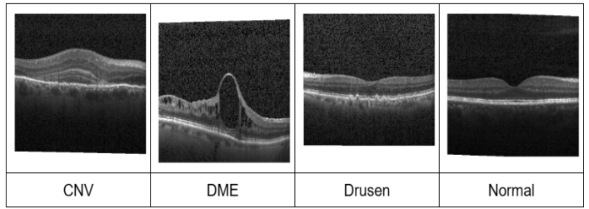
Fig. 2. Sample images of OCT2017

- The model requires nearly 3,75,000 learnable parameters which is very light weight model compare to whatever models have been implemented till now in best of our knowledge.
- The model was evaluated on the standard evaluation parameters and a proper ablation study has also been carried out to represent the best effectiveness of it.

Method
The detailed architecture of the proposed framework is shown in Fig. 6. The proposed framework mainly has five working modules. The first one is the input datasets, secondly the preprocessing and augmentation, thirdly a raw CNN architecture with SE blocks, the second last module is selecting a proper optimizer for the multiclass classification and the last one is the evaluation of the model using two different datasets.

- Data Preparation
The OCT-C8 dataset [23] contains 8 classes: Drusen, MH, AMD, CNV, CSR, DME, DR, and Normal. There are 2,800 validation and test photos (350 per class) and 18,400 training images (2,300 per class). Feature extraction is more difficult because each image has a resolution of 96 dpi with a 24-bit depth and contains noise and different intensity patterns. The sample images for each class are shown in Fig.1.
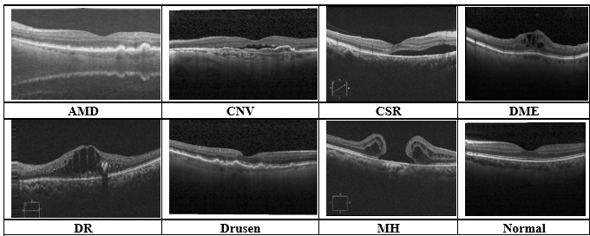
Fig. 1. Sample images of OCT-C8 dataset

The AMD and Drusen classes are more difficult to classify because of their similar visual attributes, as seen in Fig.1. Diverse training samples are produced by applying data augmentation to all classes in order to enhance model generalization and decrease misclassification.
The OCT2017 dataset [15] comprises 83,484 training photos, 968 test images, and 32 validation images, divided into four classes: CNV, DME, Drusen, and Normal. While example samples are shown Fig. 2, the training images vary in size and contain noise.

Data Augmentation
By transforming the source images, image augmentation creates a variety of training examples that aid CNN in learning minor differences across comparable classes. This lessens overfitting, increases generalization, and improves feature representation. Table 2 lists the augmentation settings utilized in the suggested strategy, which creates augmented images during training without storing them permanently.

Table 2. Configuration Details of Image Transformation Techniques
Parameter Name | Parameter Value
Pixel value normalization | 1./255
Rotation angle | 20
Horizontal shift | 0.1
Height shift | 0.1
Zoom factor | 0.2
Horizontal flipping | True
Shear intensity | 0.1
Fill mode | Nearest

Classification performance may be impacted by medical OCT dataset’s frequent class imbalance and low picture variety. Augmentation methods including rotation, flipping, zooming, shearing, and shifting are used to create a variety of training samples in order to increase robustness. This helps the model acquire discriminative features, lessen overfitting, and improve generalisation to previously encountered clinical images.

Squeeze-and-Excitation Blocks
The Squeeze-and-Excitation (SE) block [25] by finding the most informative feature channels and simulating channel-wise dependencies, it enhances CNN feature learning. It produces more selective representations of features by enhancing significant traits while suppressing less important ones. The overall architecture for SE block is depicted in Fig. 3.
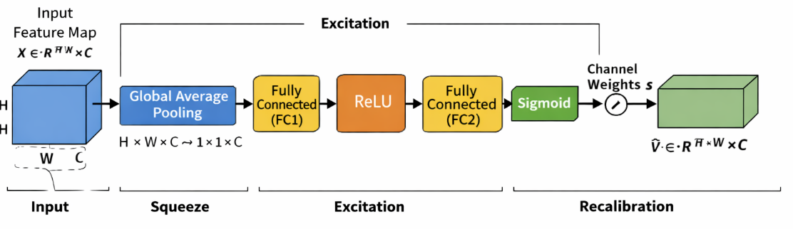
Fig. 3. Architecture of SE block

The operation of the SE block is divided into three key stages: squeeze, excitation, and recalibration. In the squeeze stage, global average pooling is applied to the input feature map $X ∈R^{H* W* C}$ to produce a channel-wise descriptor. In this stage, each channel's spatial dimensions H×W are reduced into one representative value, effectively capturing the global distribution of feature responses. Mathematically, the output of the squeeze operation for the Cth channel is computed as Eq. (1) where Z_{c}​ represents the aggregated statistic of the Cth channel. This descriptor encodes the global contextual information and reflects the overall importance of each channel.

$$Z_{c}=\frac{1}{H*W}\sum_{i=1}^{H}{\sum_{j=1}^{W}{X_{c}\left(i,j\right)}}$$ | (1)

After the squeeze stage, the excitation module learns the importance of each channel using two dense layers with a bottleneck structure. ReLU [26] and sigmoid activations generate normalized channel-wise weights that emphasize informative features while reducing computational cost. This process can be expressed as Eq. (2)

$$S= σ(W_{2}*δ\left(W_{1}*z\right))$$ | (2)

where “z” is the squeezed vector, W₁​ and W₂​ are the learnable parameters of the fully connected layers, δ denotes the ReLU [26] activation, and σ represents the sigmoid function. As stated in Eq. (3), the learnt channel weights are applied to the feature map during the recalibration stage, boosting significant features while suppressing less significant ones.

$$\tilde{X}=s_{c}*X_{c}$$ | (3)

where S_{c}​ is the learned weight for the Cth channel. This feature refinement process improves the network's ability to learn meaningful channel-wise information by giving greater emphasis to the most pertinent attributes while simultaneously diminishing the impact of less beneficial ones. As a result, the model achieves better classification performance with only a small increase in computational cost.

Adam optimizer
The Adam optimizer is a widely used method for training deep learning models due to its ability to perform well in a variety of scenarios. It integrates the concepts of adaptive learning and momentum, allowing the model to adjust how much each parameter is updated during training. Instead of using the same learning rate for all parameters, Adam adapts it based on the behavior of the gradients, which helps the model learn more efficiently and with better stability. In a simple form, the update step can be written as Eq. (4).

$$θ= θ- α* \frac{m}{\left(\sqrt{v}\right)+\left(∈\right)}$$ | (4)

where m captures the average of past gradients and v represents the average of their squared values. These estimates are continuously updated during training, helping the optimizer adapt to the shape of the loss function. Because of this adaptive behaviour, Adam tends to converge faster and requires less manual tuning compared to traditional optimization methods. It performs particularly well in problems involving large datasets, high-dimensional parameters, or noisy gradients. For these reasons, Adam has become a standard choice in many deep learning applications and is often selected as a default optimizer in practical implementations.

CNN Architecture
The proposed CNN processes 200×200×3 OCT images through successive convolution and max-pooling layers to learn hierarchical image features. SE blocks are incorporated after each stage to emphasize important feature channels while suppressing less relevant ones. The gradual increase in filters enables effective feature extraction, leading to improved retinal OCT image classification.
The extracted feature maps are condensed using global average pooling and passed to a 512-neuron dense layer with 0.3 dropout to improve generalization. A softmax layer then produces the final class predictions for the OCT-C8 and OCT2017 datasets.

$$MaxPool(x)=max⁡(x_{ij}) _{1≤i≤k,1≤j≤k}$$ | (5)

A 2x2 max-pooling procedure follows each convolutional layer to preserve the most informative features while reducing the size of the feature map by keeping just the strongest activations. As seen in Fig. 4 and Eq. (5), this increases computing efficiency and aids in the model's learning of more robust features.
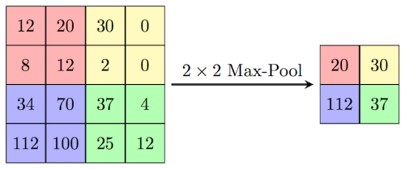
Fig. 4. Illustration of 2x2 max pooling

The ReLU [26] activation function is used throughout the CNN to introduce non-linearity by retaining positive values and suppressing negative ones. Its computational efficiency and ability to mitigate the vanishing gradient problem enable faster and more stable network convergence. The mathematical equation is depicted by Eq. (6)

F(x) = max(x, 0) | (6)
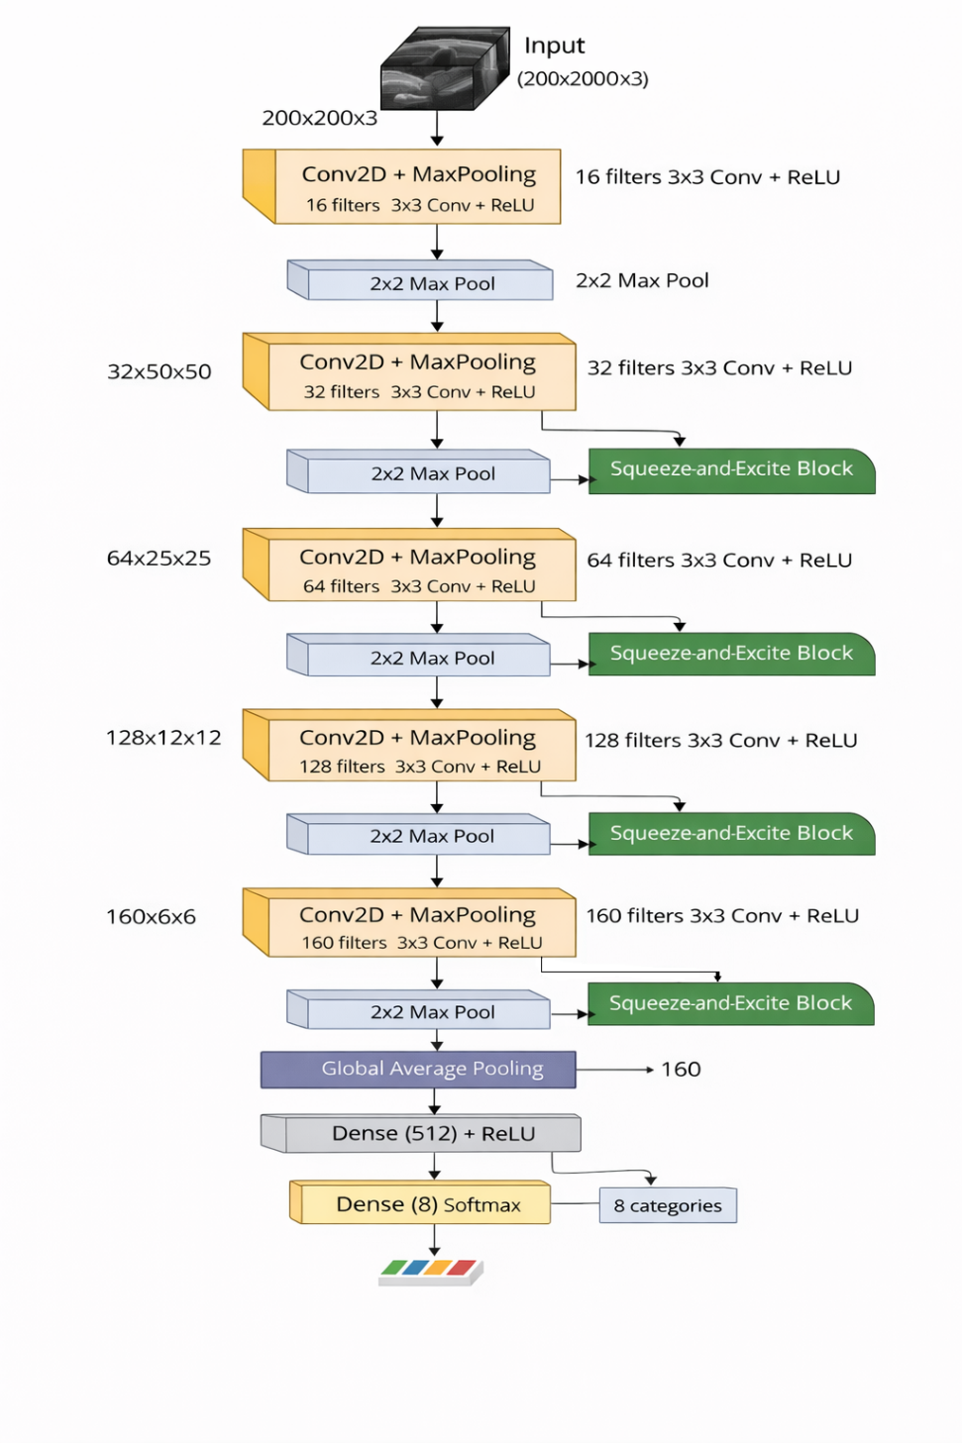
Fig.6. Proposed CNN Model (OCT-C8: 8 Class, OCT 2017: 4 Class)
The 6×6×160 feature maps are compressed by global average pooling into a 1×1×160 feature vector following the final convolution and max-pooling stage, and then they are sent to a 512-neuron dense layer for discriminative feature learning. To lessen overfitting and enhance model generalisation, a dropout rate of 0.3 is used during training. Eight neurons are used in the last output layer for the OCT-C8 [23] dataset and four neurons for the OCT2017 [15] dataset, with each neuron representing a distinct class to generate the final classification results. The last layer uses the softmax activation function to calculate the likelihood of each output class. Using these probabilities, the framework assigns the input picture to the class with the greatest confidence score. The suggested model minimizes the discrepancy between the true and predicted class labels during training by using categorical cross-entropy loss for multi-class classification. By integrating momentum and adaptive learning rates, the Adam optimizer updates adaptive parameters, facilitating quicker, more reliable, and effective convergence.
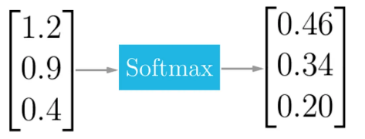
Fig. 5. Softmax layer output illustrating class probabilities

Eq. (7) defines adaptive estimates of the first and second moments of the gradients, which the Adam optimizer uses to update the model parameters. It is a good fit for the suggested CNN model because of its quick convergence, low hyperparameter adjustment, and stable optimization.
$$θ= θ- α* \frac{m}{\left(\sqrt{v}\right)+\left(∈\right)}$$ | (7)

$${σ(z)}_{j}= \frac{e^{{(z)}_{j}}}{\sum_{k=1}^{K}{e^{{(z)}_{k}}}}$$ | (8)

The mathematical formulation of the softmax function is presented in Eq. (8), while its response pattern is illustrated in Fig. 5. The function transforms the raw output values of the network into normalized probability scores ranging from 0 to 1, with the total probability across all classes equal to one. In Eq. (8), Z represents the input vector received by the output layer, and j refers to an individual output neuron, where j = 1, 2, ..., K.

Fig. 5. Softmax layer output illustrating class probabilities

Evaluation Setup and Experimental Findings

On an AMD Ryzen 7 5700G (3.80 GHz) CPU with 16 GB RAM, the suggested model was developed in Python using Keras, TensorFlow, scikit-learn, and Matplotlib. Using early stopping (patience = 20), CNN training was carried out for up to 100 epochs, maintaining the optimal weights at epoch 31 for OCT2017 [15] and epoch 63 for OCT-C8 [23]. OCT-C8 had 18,400 training and 2,800 validation and testing samples, whereas OCT2017 had 83,484 training, 32 validation, and 968 testing samples.
Using a maximum of 100 training epochs with early stopping to avoid overfitting and enhance generalisation, the suggested CNN-SE model was assessed on the OCT2017 and OCT-C8 datasets. The computational efficiency of the lightweight design was demonstrated by the training and testing times of roughly 13 h/109 ms for OCT2017 and 6 h/144 ms for OCT-C8. Stable learning was made possible by the combination of SE blocks, data augmentation, and the Adam optimiser. Performance was thoroughly evaluated using confusion matrices, ROC curves, training-validation curves, and class-wise evaluation metrics.
The training and validation loss curves for the OCT2017 and OCT-C8 datasets are shown in Fig. 7(a) and Fig. 7(b). Stable convergence and efficient generalization without overfitting are indicated by the loss decreasing smoothly in both datasets with little difference between the training and validation curves. Because of its larger training set, fewer classes, and reduced inter-class complexity, the OCT2017 dataset converges more quickly than OCT-C8. The training and validation accuracy curves for the OCT2017 and OCT-C8 datasets are shown in Fig. 8(a) and Fig. 8(b). Both datasets show a consistent rise in accuracy with training and validation curves that are closely aligned, suggesting stable learning and high generalization. The suggested model consistently produces high classification performance, even if OCT-C8 converges more slowly because of its higher-class complexity and inter-class similarity.
The confusion matrices for the OCT2017 and OCT-C8 test datasets are shown in Fig. 9(a) and Fig.9(b), respectively. With only a few misclassifications in the DME and Drusen classes, the majority of OCT2017 predictions fall along the diagonal, indicating good discriminating between the four retinal disease categories. AMD, CSR, DR, and MH are nearly perfectly classified in the OCT-C8 confusion matrix, which also shows a significant diagonal distribution. Due to their similar visual traits, there is some confusion between CNV, DME, Drusen, and Normal; nonetheless, overall classification performance is still quite accurate and reliable across all eight classes.
The OCT-C8 dataset's larger number of classes and higher inter-class similarity are the main causes of the performance gap between the two datasets. The confusion matrices show a significant diagonal distribution in spite of these difficulties, suggesting that most samples are properly identified. Misclassifications have little effect on the overall outcomes and are restricted to visually comparable retinal disease types. These results show that the suggested CNN-SE model is robust, reliable, and capable of significant generalisation across both datasets.
The ROC curves for the OCT2017 and OCT-C8 datasets are shown in Fig. 10(a) and Fig. 10(b). All classes attain curves near the upper-left corner, suggesting high true positive rates with low false positive rates. The outstanding discriminative capabilities of the suggested CNN-SE model is demonstrated by the nearly flawless AUC values for OCT2017 and the continuously high AUC values for OCT-C8.
Table 3 and Table 4 provide an overview of the suggested CNN-SE model's quantitative performance. The model's overall accuracy on the OCT2017 dataset was 99.00%, with macro and weighted averages of 0.99. The Normal class achieved flawless precision, recall, and F1-score (1.00). DME and Drusen recorded 0.99 F1-scores with 242 testing samples each, whereas the CNV class attained 0.97 precision, 1.00 recall, and 0.98 F1-score. Across all categories of retinal diseases, our results show balanced, dependable, and extremely accurate categorisation performance.

$$Precision= \frac{True Positives}{True Positives+False Positives}$$ | (9)

$$Recall= \frac{True Positives}{True Positives+False Negatives}$$ | (10)

$$F1 Score=2* \frac{Precision*Recall}{Precision+Recall}$$ | (11)

Table 3. Class-wise Classification Results of the
Proposed CNN–SE Model on the OCT2017 Dataset

 | Precision | Recall | F1-score | Support
Class
CNV | 0.97 | 1.00 | 0.98 | 242
DME | 1.00 | 0.98 | 0.99 | 242
Drusen | 0.99 | 0.98 | 0.99 | 242
Normal | 1.00 | 1.00 | 1.00 | 242
Accuracy |  |  | 0.99 | 968
Macro Avg | 0.99 | 0.99 | 0.99 | 968
Weighted Avg | 0.99 | 0.99 | 0.99 | 968

Table 4. Class-wise Classification Results of the
Proposed CNN–SE Model on the OCT-C8 Dataset
 | Precision | Recall | F1-score | Support
Class
AMD | 1.00 | 1.00 | 1.00 | 350
CNV | 0.90 | 0.95 | 0.93 | 350
CSR | 1.00 | 1.00 | 1.00 | 350
DME | 0.98 | 0.89 | 0.93 | 350
DR | 1.00 | 0.99 | 1.00 | 350
Drusen | 0.94 | 0.93 | 0.94 | 350
MH | 0.99 | 1.00 | 1.00 | 350
Normal | 0.92 | 0.97 | 0.94 | 350
Accuracy |  |  | 0.97 | 2800
Macro Avg | 0.97 | 0.97 | 0.97 | 2800
Weighted Avg | 0.97 | 0.97 | 0.97 | 2800

Ablation Study
To systematically assess the individual contributions of the SE blocks, data augmentation, and optimizer selection under the same training and testing settings, ablation research was carried out using the OCT2017 and OCT-C8 datasets.
At the beginning, a basic CNN model was trained without including SE blocks and without applying data augmentation. We call it Model A for the denotation which is shown in Fig. 6 in that SE blocks are not included. This architecture showed lower classification performance, especially for classes like CNV, DME, and Drusen where the features are quite similar. Since no augmentation was used, the training data lacked variation, which made it harder for the model to generalize well on unseen test dataset images. In the second model implementation: Model B, data augmentation was added while keeping the model architecture the same as Model A. With more varied training samples, the model was able to learn better patterns, which improved overall accuracy and reduced overfitting. There was also a clear improvement in recall, especially for minority classes and those with similar visual features.

Table 5. Ablation study of different model implementations
Model | SE Blocks | Data Augmentation | Optimizer | Accuracy (OCT2017) | Accuracy (OCT-C8)
Model A | No | No | Adam | 96.2% | 92.8%
Model B | No | Yes | Adam | 97.8% | 94.6%
Model C | Yes | No | Adam | 97.9% | 94.87%
Model D | Yes | Yes | SGD | 95.3% | 94.1%
Model E (Proposed Model) | Yes | Yes | Adam | 99.0% | 97.0%

While Model D indicated that substituting SGD for Adam led to slower convergence and somewhat reduced accuracy, Model C showed that adding SE blocks enhanced feature representation and classification performance, especially for structurally related retinal disorders. By strengthening feature learning, boosting generalization, and guaranteeing stable optimization, the suggested Model E—which combined SE blocks, data augmentation, and the Adam optimizer—achieved the best overall performance. The ablation findings verify that each element adds to the model's efficacy, and when combined, they produce the most robust and well-balanced retinal OCT image. The results of the ablation study are briefly presented in Table 5.

Table 6. Comparison with existing approaches
Publication Year | References | Approach | Acc (OCT2017 Dataset) | Acc (OCT-C8 Dataset)
2019 | Diaz et al. [27] | Conventional CNN-based classifier | 93 | Not Implemented
2019 | L.Huang et al. [14] | Layer-guided convolutional neural network | 88.4
2020 | Saraiva et al. [28] | Deep CNN architecture | 93.3
2021 | J Kim et al. [16] | Two binary CNN variants (Model 1 / Model 2 with high computational complexity) | 98.1/98.7
2023 | Hassan E et al [18] | Enhanced Optical Coherence Tomography (EOCT)-based framework | 97.47
2023 | Diao et al. [17] | CNN-based classification framework | 96.93
2023 | Michael Opoku et al. [29] | Capsule network integrated with contrast-limited adaptive histogram equalization | 97.7
2024 | Stanojevi´c, M et al. [21] | Deep convolutional neural network model | 95.55
2024 | Yang J et al. [20] | CNN, EfficientNet-V2, and ResNet-based ensemble architecture | 97.89
2025 | Dave and Domadiya et al. [24] | CNN with data augmentation, exponential learning rate decay, and hybrid max–average pooling | 98.75
2026 | Proposed Model | CNN enhanced with SE blocks, Adam optimization, and global average pooling | 99.00 | 97.00

Table 6 shows a comparison of the suggested model with current techniques on the OCT2017 and OCT-C8 datasets. Compared with existing CNN-based approaches achieving 88.4%–98.75% accuracy on OCT2017, the proposed CNN-SE model with Adam optimization and global average pooling attained the highest accuracies of 99.00% on OCT2017 and 97.00% on OCT-C8, demonstrating superior feature representation and generalization.

Conclusion and Future Work
In order to improve feature learning and generalization, this study integrates SE blocks, data augmentation, and the Adam optimizer into a lightweight CNN-SE framework for retinal OCT picture categorization. Without depending on transfer learning or intricate structures, the suggested model maintains low computational complexity and delivers good classification accuracy with just 375,000 learnable parameters.
With steady convergence and robust class discrimination, the suggested model obtained 99% and 97% accuracy on the OCT2017 and OCT-C8 datasets, respectively. The ablation investigation confirms that SE blocks, data augmentation, and the Adam optimiser are useful for enhancing overall performance and generalisation.
Even though the model gives strong results, there is still scope to improve it further. It can be tested on larger and more diverse clinical datasets to check how well it works in real-world conditions. Adding simple visualization methods like Grad-CAM or CAM can help doctors understand which areas the model is focusing on for the real time classifications of the anomalies. Additionally, the model may be enhanced by experimenting with other structures or adjusting parameters and hyperparameters for better performance in overlapping feature classes. This work shows that a simple and well-designed model can give strong results without making things too much complex. With some improvements and real-world testing, it can be useful in supporting faster and more reliable diagnosis in practice.

Acknowledgment
NA

Funding
NA

Data Availability
The datasets used in the research are publicly available and we have cited it properly in the paper [15] and [23].

Author Contribution
Both authors have contributed equally to the proposed research

Declarations
The authors declare no conflict of interest.

References

[1] T. Ojala, M. Pietikainen, and T. Maenpaa, “Multiresolution gray-scale and rotation invariant texture classification with local binary patterns,” IEEE Trans. Pattern Anal. Mach. Intell., vol. 24, no. 7, pp. 971–987, Jul. 2002, doi: 10.1109/TPAMI.2002.1017623.
[2] N. Dalal and B. Triggs, “Histograms of Oriented Gradients for Human Detection,” in 2005 IEEE Computer Society Conference on Computer Vision and Pattern Recognition (CVPR’05), IEEE, pp. 886–893. doi: 10.1109/CVPR.2005.177.
[3] R. M. Haralick, K. Shanmugam, and I. Dinstein, “Textural Features for Image Classification,” IEEE Trans. Syst. Man Cybern., vol. SMC-3, no. 6, pp. 610–621, Nov. 1973, doi: 10.1109/TSMC.1973.4309314.
[4] M. A. Hearst, S. T. Dumais, E. Osuna, J. Platt, and B. Scholkopf, “Support vector machines,” IEEE Intelligent Systems and their Applications, vol. 13, no. 4, pp. 18–28, Jul. 1998, doi: 10.1109/5254.708428.
[5] B. Zoph, V. Vasudevan, J. Shlens, and Q. V. Le, “Learning Transferable Architectures for Scalable Image Recognition,” in 2018 IEEE/CVF Conference on Computer Vision and Pattern Recognition, IEEE, Jun. 2018, pp. 8697–8710. doi: 10.1109/CVPR.2018.00907.
[6] A. Krizhevsky, I. Sutskever, and G. E. Hinton, “ImageNet classification with deep convolutional neural networks,” Commun. ACM, vol. 60, no. 6, pp. 84–90, May 2017, doi: 10.1145/3065386.
[7] K. Simonyan and A. Zisserman, “Very Deep Convolutional Networks for Large-Scale Image Recognition,” Apr. 2015.
[8] K. He, X. Zhang, S. Ren, and J. Sun, “Deep Residual Learning for Image Recognition,” in 2016 IEEE Conference on Computer Vision and Pattern Recognition (CVPR), IEEE, Jun. 2016, pp. 770–778. doi: 10.1109/CVPR.2016.90.
[9] C. Szegedy et al., “Going deeper with convolutions,” in 2015 IEEE Conference on Computer Vision and Pattern Recognition (CVPR), IEEE, Jun. 2015, pp. 1–9. doi: 10.1109/CVPR.2015.7298594.
[10] P. P. Srinivasan et al., “Fully automated detection of diabetic macular edema and dry age-related macular degeneration from optical coherence tomography images,” Biomed. Opt. Express, vol. 5, no. 10, p. 3568, Oct. 2014, doi: 10.1364/BOE.5.003568.
[11] Y.-Y. Liu et al., “Computerized Macular Pathology Diagnosis in Spectral Domain Optical Coherence Tomography Scans Based on Multiscale Texture and Shape Features,” Investigative Opthalmology & Visual Science, vol. 52, no. 11, p. 8316, Oct. 2011, doi: 10.1167/iovs.10-7012.
[12] Jianixn Wu and J. M. Rehg, “Where am I: Place instance and category recognition using spatial PACT,” in 2008 IEEE Conference on Computer Vision and Pattern Recognition, IEEE, Jun. 2008, pp. 1–8. doi: 10.1109/CVPR.2008.4587627.
[13] K. Alsaih et al., “Classification of SD-OCT volumes with multi pyramids, LBP and HOG descriptors: Application to DME detections,” in 2016 38th Annual International Conference of the IEEE Engineering in Medicine and Biology Society (EMBC), IEEE, Aug. 2016, pp. 1344–1347. doi: 10.1109/EMBC.2016.7590956.
[14] L. Huang, X. He, L. Fang, H. Rabbani, and X. Chen, “Automatic Classification of Retinal Optical Coherence Tomography Images With Layer Guided Convolutional Neural Network,” IEEE Signal Process. Lett., vol. 26, no. 7, pp. 1026–1030, Jul. 2019, doi: 10.1109/LSP.2019.2917779.
[15] D. S. Kermany et al., “Identifying Medical Diagnoses and Treatable Diseases by Image-Based Deep Learning,” Cell, vol. 172, no. 5, pp. 1122-1131.e9, Feb. 2018, doi: 10.1016/j.cell.2018.02.010.
[16] J. Kim and L. Tran, “Retinal Disease Classification from OCT Images Using Deep Learning Algorithms,” in 2021 IEEE Conference on Computational Intelligence in Bioinformatics and Computational Biology (CIBCB), IEEE, Oct. 2021, pp. 1–6. doi: 10.1109/CIBCB49929.2021.9562919.
[17] S. Diao et al., “Classification and segmentation of OCT images for age-related macular degeneration based on dual guidance networks,” Biomed. Signal Process. Control, vol. 84, p. 104810, Jul. 2023, doi: 10.1016/j.bspc.2023.104810.
[18] E. Hassan et al., “Enhanced Deep Learning Model for Classification of Retinal Optical Coherence Tomography Images,” Sensors, vol. 23, no. 12, p. 5393, Jun. 2023, doi: 10.3390/s23125393.
[19] D. Paul, A. Tewari, S. Ghosh, and K. C. Santosh, “OCTx: Ensembled Deep Learning Model to Detect Retinal Disorders,” in 2020 IEEE 33rd International Symposium on Computer-Based Medical Systems (CBMS), IEEE, Jul. 2020, pp. 526–531. doi: 10.1109/CBMS49503.2020.00105.
[20] J. Yang, G. Wang, X. Xiao, M. Bao, and G. Tian, “Explainable ensemble learning method for OCT detection with transfer learning,” PLoS One, vol. 19, no. 3, p. e0296175, Mar. 2024, doi: 10.1371/journal.pone.0296175.
[21] M. Stanojević, D. Drašković, and B. Nikolić, “Retinal disease classification based on optical coherence tomography images using convolutional neural networks,” J. Electron. Imaging, vol. 32, no. 03, Nov. 2022, doi: 10.1117/1.JEI.32.3.032004.
[22] M. Selvarajan and M. B. N. M, “Impact of Optimizer Algorithm on NasNetMobile Model for Eight-class Retinal Disease Classification from OCT Images,” Journal of Electronics, Electromedical Engineering, and Medical Informatics, vol. 8, no. 2, pp. 490–503, Mar. 2026, doi: 10.35882/jeeemi.v8i2.1464.
[23] Obuli Sai Naren, “Retinal OCT Image Classification - C8 [Data set],” https://www.kaggle.com/datasets/obulisainaren/retinal-oct-c8/versions/2. Accessed: Jul. 20, 2026. [Online]. Available: https://doi.org/10.34740/KAGGLE/DSV/2736749
[24] P. R. Dave and N. H. Domadiya, “Lightweight deep learning approach for retinal OCT image classification: A CNN with hybrid pooling and optimized learning,” International Journal of Informatics and Communication Technology (IJ-ICT), vol. 15, no. 1, p. 414, Mar. 2026, doi: 10.11591/ijict.v15i1.pp414-427.
[25] J. Hu, L. Shen, and G. Sun, “Squeeze-and-Excitation Networks,” in 2018 IEEE/CVF Conference on Computer Vision and Pattern Recognition, IEEE, Jun. 2018, pp. 7132–7141. doi: 10.1109/CVPR.2018.00745.
[26] V. Nair and G. E. Hinton, “Rectified Linear Units Improve Restricted Boltzmann Machines.”
[27] M. Díaz, J. Novo, P. Cutrín, F. Gómez-Ulla, M. G. Penedo, and M. Ortega, “Automatic segmentation of the foveal avascular zone in ophthalmological OCT-A images,” PLoS One, vol. 14, no. 2, p. e0212364, Feb. 2019, doi: 10.1371/journal.pone.0212364.
[28] A. A. Saraiva et al., “Classification of Optical Coherence Tomography using Convolutional Neural Networks,” in BIOINFORMATICS 2020 - 11th International Conference on Bioinformatics Models, Methods and Algorithms, Proceedings; Part of 13th International Joint Conference on Biomedical Engineering Systems and Technologies, BIOSTEC 2020, SciTePress, 2020, pp. 168–175. doi: 10.5220/0009091001680175.
[29] M. Opoku, B. A. Weyori, A. F. Adekoya, and K. Adu, “CLAHE-CapsNet: Efficient retina optical coherence tomography classification using capsule networks with contrast limited adaptive histogram equalization,” PLoS One, vol. 18, no. 11, p. e0288663, Nov. 2023, doi: 10.1371/journal.pone.0288663.

Author Biography (ARIAL 10, BOLD, H1)

Required Information:
- Full name: Parth R. Dave and Nikunj H. Domadiya
- Email address for each author: 1st Author (prd7889@gmail.com,parthdave.ce@ldce.ac.in), 2nd Author domadiyanikunj002@gmail.com
- Social media account:
- ORCID iD: Parth R. Dave (https://orcid.org/0000-0003-1922-0997) , Nikunj H. Domadiya (https://orcid.org/0000-0002-5804-9910)

 | Prof. Parth R. Davewas born at Halol in Gujarat, India on7th August, 1989. Prof. Dave completed B.E. and M. Tech with specialization in Computer Engineering from Dharmsinh Desai University, Nadiad, Gujarat, India in the years 2011 and 2013 respectively. The author’s major field of study covers machine learning, deep learning, image processing and multimedia information retrieval. He had worked as an Assistant Professor in the Computer Engineering Department at Dharmsinh Desai University, Nadiad, Gujarat, India from 2013 to 2020. He is currently working as an Assistant Professor in the Computer Engineering Department at L. D. College of Engineering, Ahmedabad, Gujarat, India since 2020. He delivers expert talks and serves as reviewer in international conferences and journals. He has also presented papers in International Journals, IEEE Conferences. He can be contacted at email: prd7889@gmail.com.
 | Nikunj H. Domadiya  completed M. Tech and Ph.D. from NIT-Surat, Gujarat, India in the years 2013 and 2020 respectively. The author’s major field of reaserch covers Data Privacy and Security, Machine learning, Deep learning, and multimedia information retrieval. He is currently working as an Assistant Professor in the Computer Engineering Department at L. D. College of Engineering, Ahmedabad, Gujarat, India since 2020. He can be contacted at email: domadiyanikunj002@gmail.com

Each author is required to provide a cover image as shown example below

